Pedro Dal Bo:

"Cooperation under the Shadow of the Future: experimental evidence from infinitely repeated games"

http://www.econ.brown.edu/fac/Pedro_Dal_Bo/theshadow.pdf

Table 2: Stage game payoffs in points

PD1 |  |  |  |  | PD2
 |  | Blue Player |  |  | Blue Player
 |  | C | D |  | C | D
Red Player | C | 65 , 65 | 10 , 100 |  | 75 , 75 | 10 , 100
Red Player | D | 100 , 10 | 35 , 35 |  | 100 , 10 | 45 , 45

All payoffs in the game were in points. At the end of each session, the points earned by each subject were converted into dollars at the exchange rate 200 points=$1 and paid privately in cash. In addition, subjects were paid a 5 dollar show up fee
Rotating matching

Repetition

Infinite horizon
expected length
Finite horizon
subjects played all infinite or all finite
done in both orders – increasing length and decreasing length

Theory

 | PD1 | PD2
0 | DD | DD
½ | DD, DC, CD | DD, CC
¾ | All | All

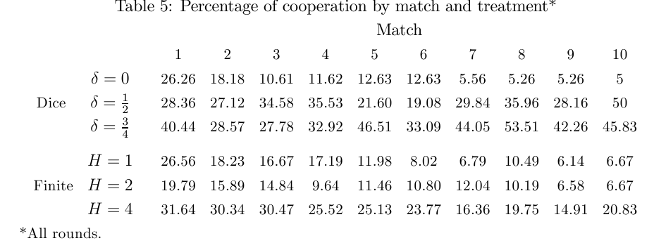
Results on Cooperation

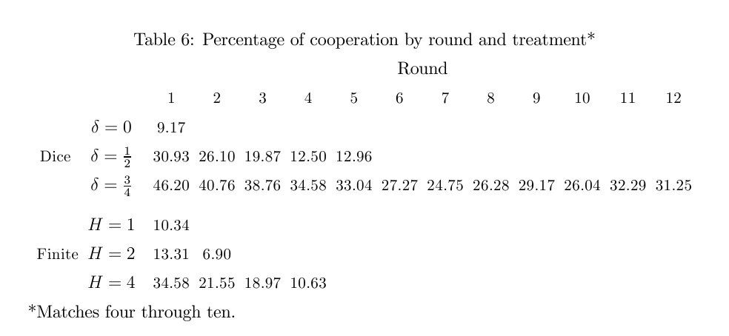
Focus on matches 4-10

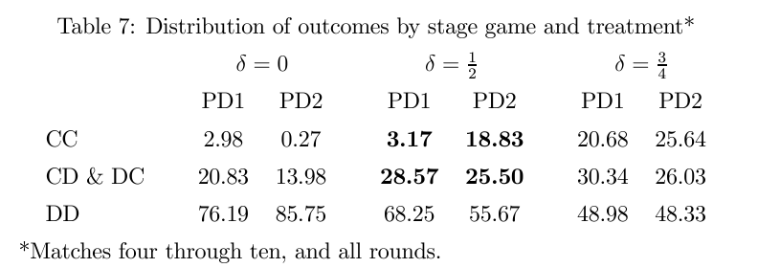
Joint Outcomes

Reciprocal Altruism

- one shot game or final period of the two period games with a definite ending
- experienced players: after six or more matches
- probability of cooperation in the final period
in one shot game: 6.4%
if you cheat in the first period of two shot: 3.2%
if you cooperate in the first period of one shot: 21%

